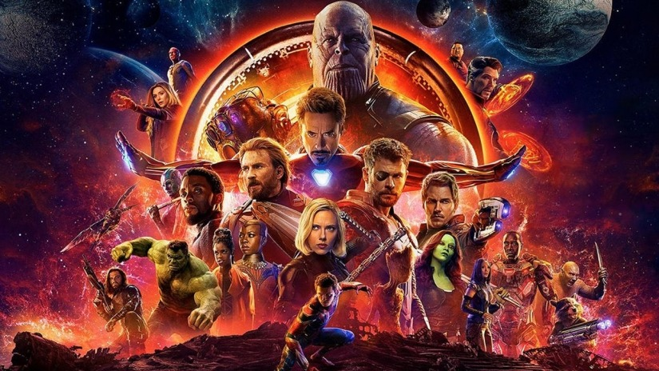
REVIEW
It’s been six years since Marvel first assembled the Avengers in a blockbuster hit that was, plainly, as good as the hype suggested. Since then, Marvel’s star has only continued to rise: they’ve smashed box office records, turned bit-parts into fan-favourites, and changed the face of blockbuster movies such that everyone wants to know how they can do what Marvel does. In light of all this, Infinity War isn’t so much the ultimate expression of their philosophy as it is two and a half hours of unrestrained fan-service – because having proven that they can tell a story with virtually anyone, they now demonstrate how to tell a story with virtually everyone.
And to be fair, there is a story here. It’s about Thanos collecting the Infinity Stones and our heroes, in all their shapes and sizes, attempting to stop him. If that sounds thin, it’s because it sort of is: this is the first Marvel film that isn’t at all about character in any material way. In the past, the studio’s philosophy has been to put the journey at the heart of all they do, with varying degrees of success. Infinity War dispenses with personal growth or ideological conflict and instead says “you know these characters, we know these characters… let’s just have some fun watching them bounce off another.”
And boy, do we have fun.

The structure of the film relies heavily on unlikely team-ups and side-quests, but there’s so much glee in simply spending time with the characters that it never remotely wears thin. Meanwhile Thanos, a villain worthy of his stature, swaggers around the screen pursuing his goal so sincerely and doggedly that you almost start to root for him. Even when he wants nothing more than to quit, Thanos is driven to assemble the stones, and he’s got such dedication that part of you will secretly want him to do it.
It’s true that Infinity War is every bit the sequel Avengers has always deserved, which isn’t to disparage Avengers: Age of Ultron, but to say that this one does everything The Avengers did only bigger and better. It wastes no time on introductions - it wastes no time period - it’s wall-to-wall jokes, punctuated by feats of extreme coolness, beautiful character beats and surprise after surprise. If you’re a Marvel fan at all, you won’t be at all disappointed by the density of jokes and action, and whoever your favourite character in the movie is, you’ll see them get their moment. Even if your favourite character is Mantis.
Indeed, the size of the cast is such that keeping track of them all is tough, but the directors continually weave back and forth between plot threads and set pieces so that we’re never with anyone for too long, though there are times where you return to a scene only to realise you were so invested in the previous one that you’re disappointed to have moved on. It does feel a little like channel surfing between three or four Marvel movies at once, but when they’re all as good as they are, who can complain? It would be nice to have spent more time in certain locations or with certain characters, but in a movie this sprawling it’s impressive that we get enough time with anyone.
The one thing common to every part of the movie, though, is Thanos.
After a six-year build-up Marvel were under pressure to make him worth the wait, and he absolutely is. Considering that he looks like a CGI purple Bruce Willis, the fact that he’s so charismatic, interesting - almost sympathetic at times – is a real achievement. Marvel has (not undeservedly) earned the reputation of being the studio with villain problems, but the last few movies are anything to go by they may yet shake it. You may love Thanos, you may hate him, but you’ll come out of the movie knowing both who he is and what he wants, and maybe even caring about it too.
But even he isn’t the centre of the movie – he’s just a rock around which the tide is forced to flow. Ultimately, this film is an ensemble piece as only it could have been. That’s not a complaint – it’s going to take a long time for the novelty to get old, but when even when you’re bored of seeing Peter Quill and Peter Parker together there are still ideas to hang onto. There’s a thread throughout the film about characters considering what the value of a single life is, and whether there’s moral value in killing one to save many, and if so, where the line is drawn. In another film, that could have been further developed into something truly interesting, but it’s present here nonetheless, as something that drives all of the big players.
The most exciting thing about Infinity War, however, is that it’s like someone finally put an event comic on screen. Though often derided as shallow and facile, the best event stories work because you care about who makes it out of them, and are worried for what they might lose along the way, even though you know they’re going to win. Like an event comic, Avengers: Infinity War is epic and operatic, with scope and ambition. It’ll leave you simultaneously breathless and emotionally devastated – and when you’ve pulled yourself together, you’ll want to do it all over again.
5/5

